**Avalon_Nano3s’s Open Source Policies**

**Open Source Trademark Policy**

Canaan Creative Co., Ltd. open source projects may include trademarks and logos, such as 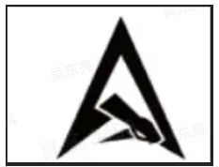, 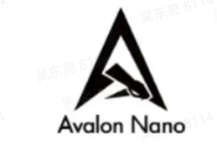 (hereinafter referred to as *Avalon Trademarks*). If you’d like to use Avalon Trademarks outside the scope of this policy, please email us at [legal@canaan-creative.com](mailto:legal@canaan-creative.com).

**Nominative Fair Use Allowed**

You may use our open source project names for discussion, commentary, and criticism, so long as your use does not suggest sponsorship, endorsement, or affiliation between you or any third-party and Avalon_Nano3s. You may not use our open source logos without permission.

**Unauthorized Use**

You may not use Avalon Trademarks in a manner inconsistent with this policy without written permission. Please do not use Avalon Trademarks as open source project names, domain names, usernames, mobile app names, or company names. As an example, you may not use Avalon Trademarks (or any of Canaan’s non-OSS trademarks) in the name of any software project.